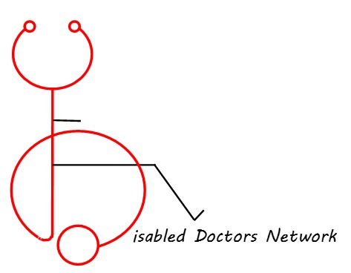
Careers Advice for Medical
Students & Doctors with Disabilities

The decision to choose medicine as a prospective career can be daunting for anyone but even more so for someone with a long-term health condition (LTC)/disability. Furthermore, making an informed decision about which Specialty training to embark on is also more complicated as there are extra things to consider.
Depending on the LTC/disability there are different factors to consider when making careers decisions; including whether or not training competences are going to be achievable, the work patterns of the Specialty and day-day clinical duties etc. A LTC/disability may have been acquired either at medical school or whilst already established in a Specialty. This can be particularly challenging but by no means insurmountable; after all, as medical students and doctors we are nothing if not creative, determined and resourceful. Many of our innate attributes and honed skills are highly transferrable not only to other medical Specialties but also to careers outside medicine.
The below advice is divided into tips for medical students and doctors in training, and includes possible suggestions for those considering switching careers.

Medical students
Careers advice is somewhat lacking, and not really tailored to students with LTC/disabilities. This is mainly because Specialties are uncertain whether they will be able to support or accommodate trainees with LTC/disabilities.

Top Tip: Be proactive, get advice early:
- Medical School careers advisors are a good initial port of call. Their advice can be generic but they should have the resources (literature/websites) and the contacts to help sign post you in the right direction.

- Make contact with Clinical Leads in Specialties you are interested in or Consultants who are active in medical student supervision or teaching.

- Personal tutors are responsible for both pastoral care and professional development – in the same way as careers advisors they can put you in touch with clinical colleagues who will have more knowledge about individual requirements for each specialty/training programme.
- The Royal Colleges have designated tutor representatives within your region – they are a great resource for curriculum and competency related questions. They will also be able to provide guidance on reasonable adjustments (see below for link to each Royal College website for their representatives)

Getting hands-on experience:
- Take opportunities to do projects e.g. audit/quality improvement as well as extra clinics or placements in the Specialties you are interested in pursuing. This will not only give you more of an idea what the Specialty involves but will look good on future job applications

- Shadowing FY1/FY2/specialty trainees within the Specialty will give you invaluable, first hand insight into the job’s clinical duties, as well as training requirements and on-call commitments. Having this knowledge will enable you to identify areas that may be challenging, and come up with possible reasonable adjustments to discuss with Royal College Representatives.

Foundation Training
- When ranking foundation programme rotations (3x rotations in FY1, 3x rotations in FY2), ideally choose rotation combinations that include one or more of the Specialties you are interested in.

- Similarly, if you are working Less than Full Time (LTFT) there may be more flexibility with rotation choice both for job shares and supernumerary posts. You may be asked to give a preference – choose Specialties you are keen on.

- Taster days – these are great opportunities to experience working in a number of different Specialties or Sub-specialties – particularly those that don’t have foundation posts e.g. Public Health, Community Paediatrics

- Study days – with permission from the Deanery, study days may be used to explore allied medical professions or fields related to medicine e.g. NHS Management, Medical Ethics and Politics…

A medical degree is highly valued by employers, as well as leadership, decision making and communication skills developed as a medical student or doctor.
For those considering switching careers to alternative professions or fields related to medicine, here is a list of possible options:
- Academia – medical research/education/tutoring
- Innovation – medical devices
- Medical law
- Medical Politics and Ethics
- Health Policy
- Public Health/Epidemiology
- Public relations and corporate communication
- NHS Management
- Civil Service – Department of Health, Healthcare Commission
- Journalism
- Medical translation
- Allied Health Professions e.g. Dietetics

Useful resources
- BMA careers
- Job descriptions of various Specialties
- Medical School Council (Information on various Specialties)

Alternative career options
- Health Careers, Health Education England – Alternative career options leaflet
- Medic Footprints website
- Medical Success website
- Career in Occupational Medicine

Royal College Representatives
- Royal College of Anaesthetists

- Royal College of Emergency Medicine

- Royal College of Surgeons

- Royal College of Psychiatrists

- Royal College of GPs

- Faculty of Intensive Care Medicine

- Royal College of Obstetricians and Gynaecologists

- Royal College of Ophthalmologists

- Royal College of Physicians

- Royal College of Paediatrics and Child Health

- Royal College of Pathologists

- Royal College of Radiologists

- Faculty of Public Health (Marijana Curic, Specialty training co-ordinator)

